
NHS South Warwickshire CCG - Experience of Clinical Commissioning Group Care

The RSN Experience of Clinical Commissioning Group Care datasheet brings together key information from the CCG Outcomes Indicator Set to inform and contextualise the position within a given CCG area. The analysis provides comparison to the overall position for England, and for the rural/urban classification in which the particular CCG sits. The sheets are editable to allow narrative descriptions and to emphasize or delete the graphs as may be appropriate for the intended use and for your local authority area/CCG.
The areas covered are:
- Patient safety incidents per 1,000 provider bed days
- Patient experience of GP out-of-hours services
- Patient experience of hospital care
- Patient experience of hospital care (access & waiting)
- Patient experience of hospital care (safe, high quality co-ordinator care)
- Patient experience of hospital care (better information, more choice)
- Patient experience of hospital care (building closer relationships)
- Patient experience of hospital care (clean, friendly, comfortable place to be)
- Responsiveness to Inpatients' personal needs

Patient safety incidents per 1,000 provider bed days
A patient safety incident is any unintended or unexpected incident which could have or did lead to harm for one or more patients receiving NHS care.
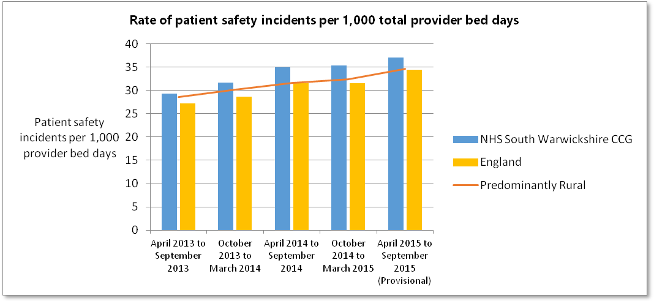
*Rate of patient safety incidents per 1,000 total provider bed days for each of a CCG’s five main providers.
Patient experience of GP out-of-hours services
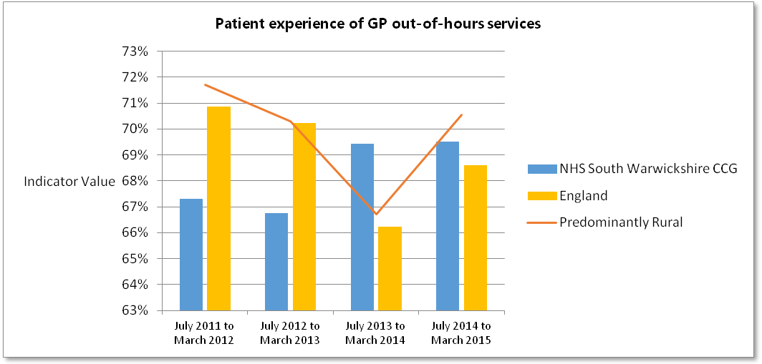
*Weighted percentage of respondents reporting a good experience.

Patient experience of hospital care
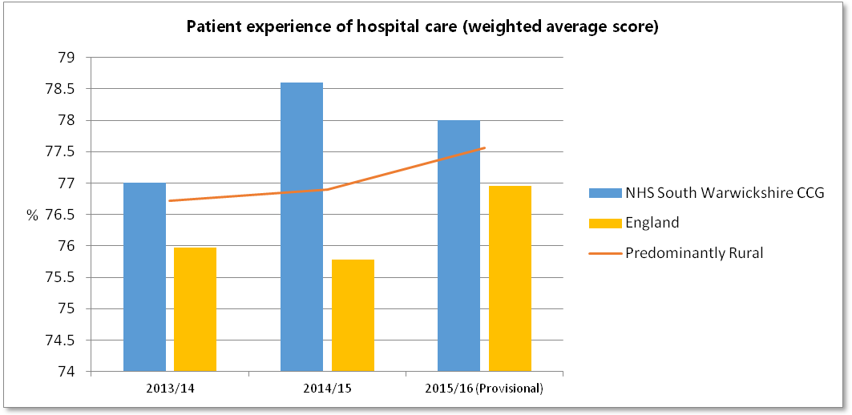
*Weighted average score from a selection of questions from the National Inpatient Survey measuring patient experience (score out of 100).

Patient experience of hospital care (access & waiting)
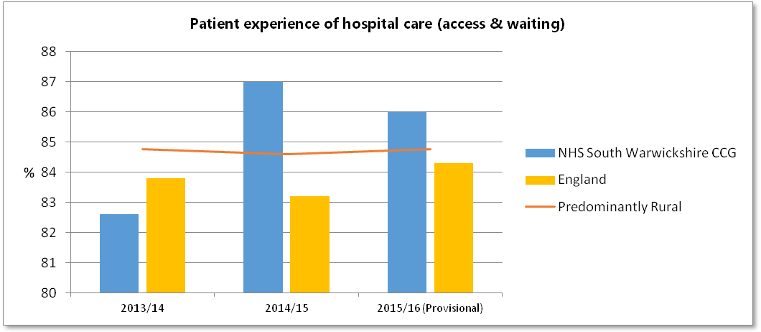
*(score out of 100).

Patient experience of hospital care (safe, high quality co-ordinator care)
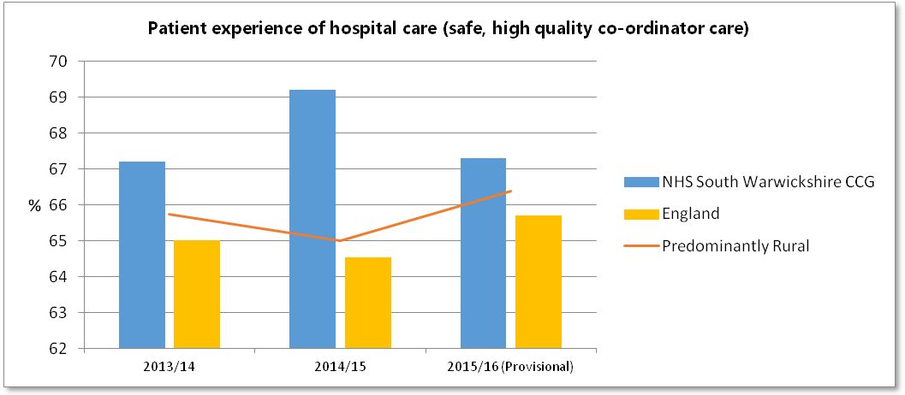
*(score out of 100).

Patient experience of hospital care (better information, more choice)
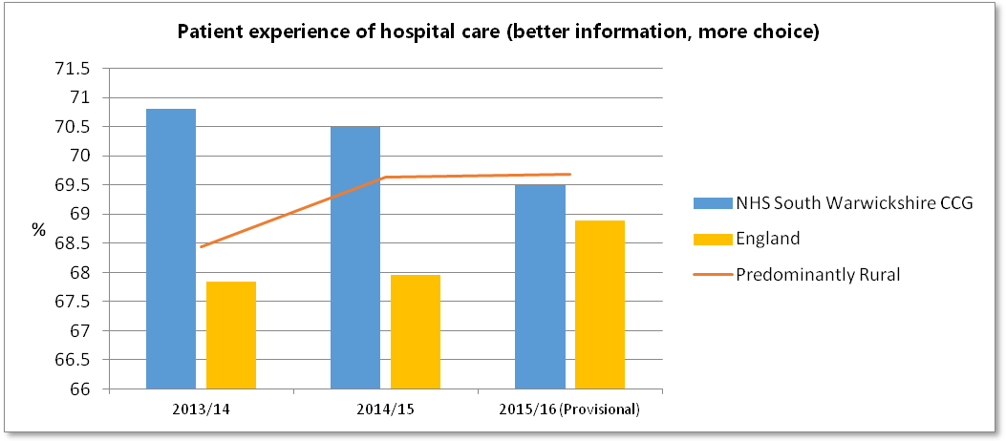
*(score out of 100).

Patient experience of hospital care (building closer relationships)
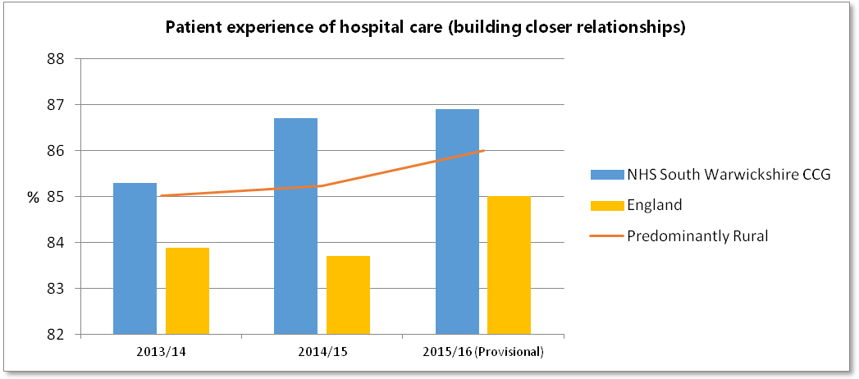
*(score out of 100).

Patient experience of hospital care (clean, friendly, comfortable place to be)
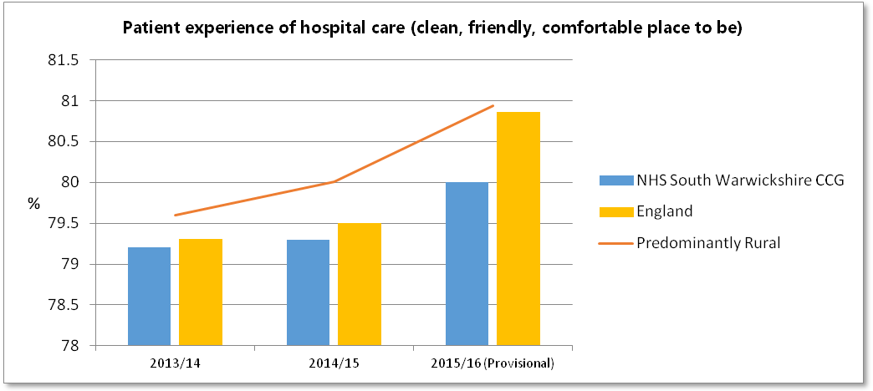
*(score out of 100).
Responsiveness to Inpatients' personal needs
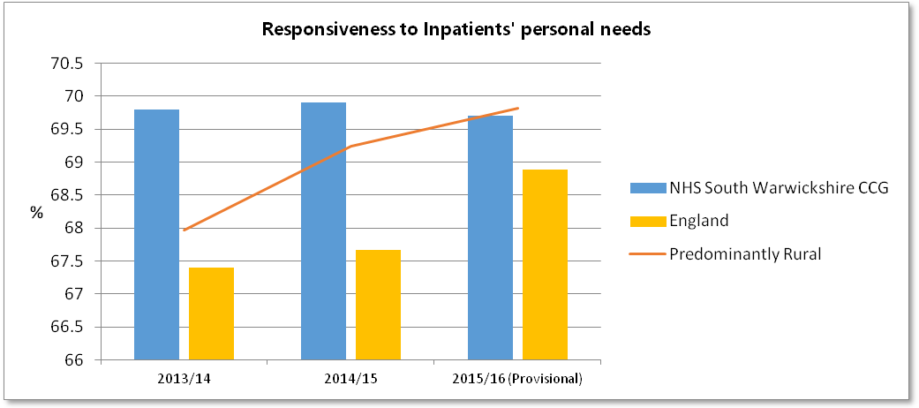
*Weighted average score from a selection of questions from the National Inpatient Survey measuring patient experience (score out of 100).
Statistical sources
Copyright © 2016, Health and Social Care Information Centre.
CCG OIS Indicator 5.1 - Patient safety incidents
CCG OIS Indicator 4.1 Patient experience of GP out-of-hours services
CCG OIS Indicator 4.2 - Patient experience of hospital care
CCG OIS Indicator 4.5 - Responsiveness to Inpatients' personal needs

