Vale of White Horse Economic Profile


The RSN Economic Profile brings together key data to inform and contextualise a local authority areas economic situation. The sheets are editable to allow narrative descriptions and to emphasize or delete the graphs as may be appropriate for the intended use and for your local authority area.
The areas covered are:
Working age population
Average hours worked and pay
Proportion of employees and enterprises in each sector
Private/public sector employment
Jobs density
Economic inactivity
Claimant counts and total benefits

Working age population

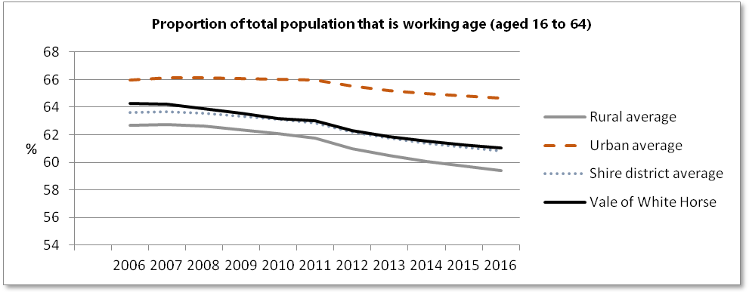
In 2016, 59% of the predominantly rural population was of working age, 16 to 64 (65% for predominantly urban).
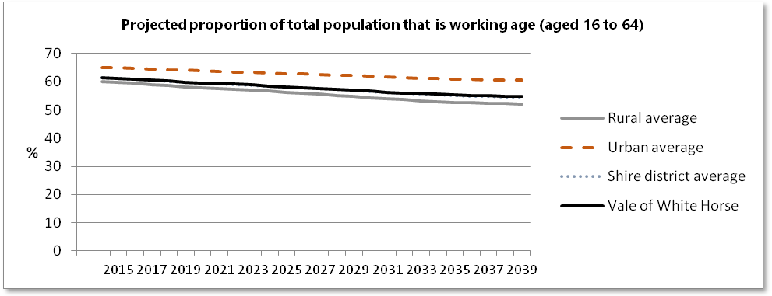
In 2039, it is expected that only 52% of the population of predominantly rural areas will be of working age (61% for predominantly urban).
Clearly for predominantly rural areas the availability of people who are within the working age group ( aged 16 to 64) is both a current issue, and one that will become more significant in the future with the proportion of total population within this age bracket diminishing each year. Naturally the age bracket that is considered to be of working age is likely to be extended in the future as people work into older age, yet it is important to understand the age demographic from which employers will be recruiting.

Average hours worked and pay

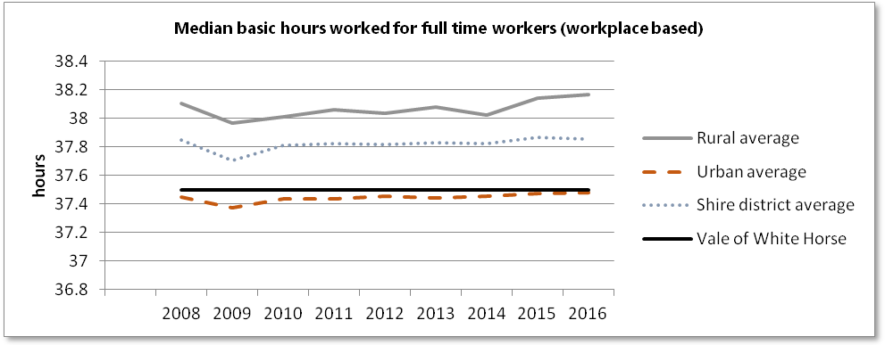

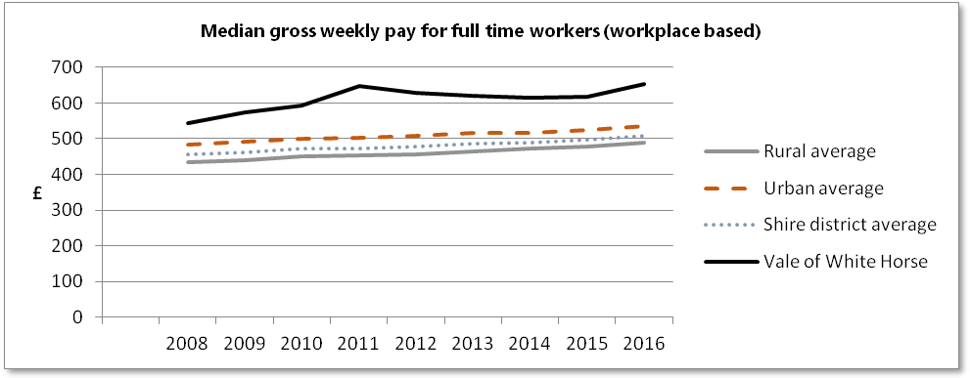

Workers in predominantly rural areas tend to work longer hours when in full time employment, but for less weekly pay, workplace based. Workplace based median gross weekly pay for full time workers is 9% greater in predominantly urban areas compared to predominantly rural areas.

Proportion of employees and enterprises in each sector

For the Vale of White Horse area:
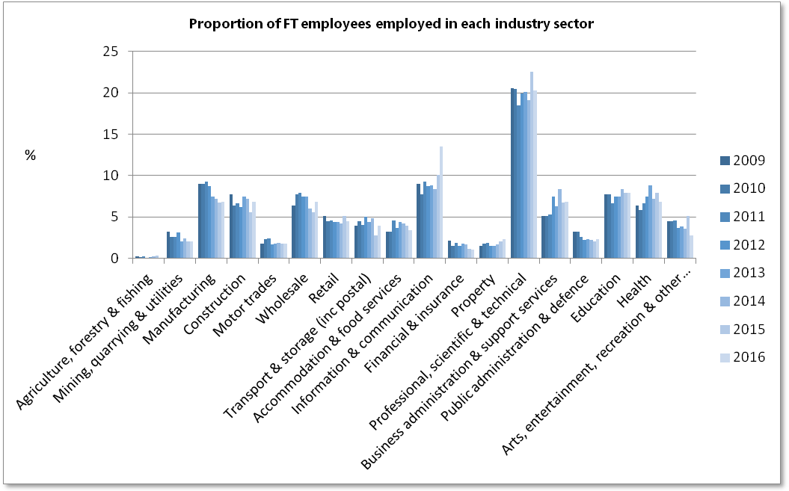
The top three sectors for employment of full time workers in Vale of White Horse in 2016 were Professional, Scientific & Technical, Information & Communication and Education with 20.3%, 13.5% and 7.9% of full-time employees employed respectively.
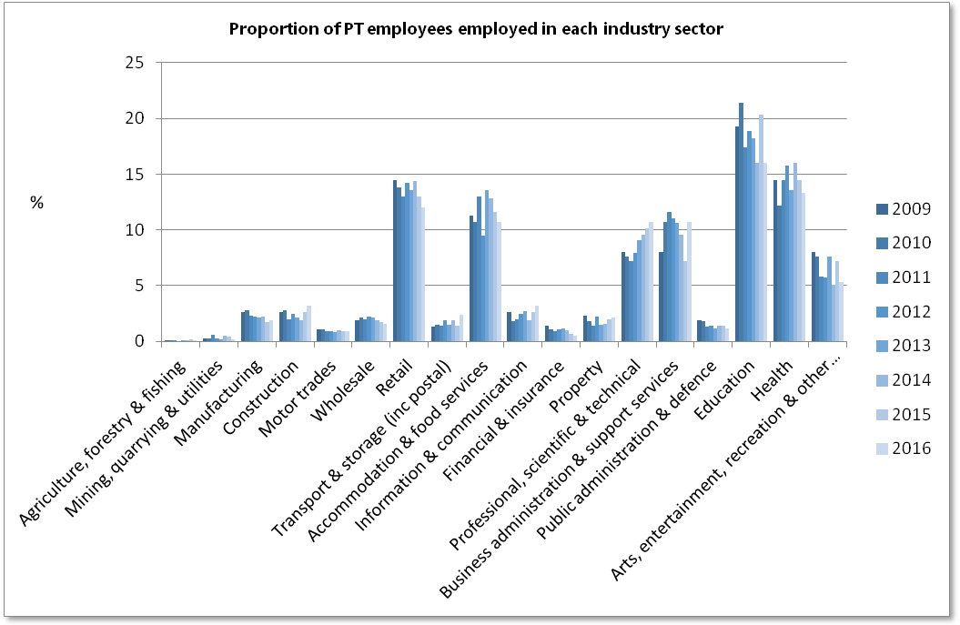

There tend to be clear industries that are significant employers of part time workers. In 2016, the top three sectors for employment of part time workers in Vale of White Horse were Education, Health and Retail at 16.0%, 13.3% and 12.0% of part-time employees employed respectively.
It is interesting to compare the proportion of employees employed in each industry sector to the proportion of enterprises in each category.
For the Vale of White Horse area:
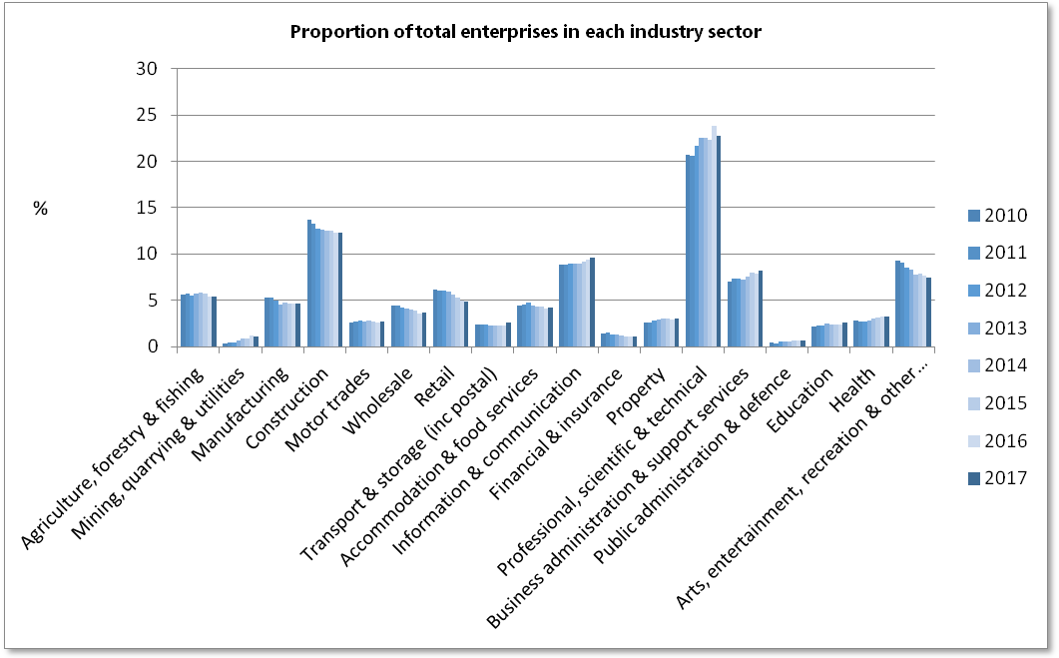
The sector with the overwhelming highest proportion of enterprises in Vale of White Horse is Professional, Scientific & Technical, with 22.7% of enterprises in 2017. Second highest proportion was within the Construction sector with 12.3% and third was Information & Communication with 9.6% of enterprises within this sector in 2017.
Time series of the proportion of total employees employed in each sector and the proportion of enterprises are given below:
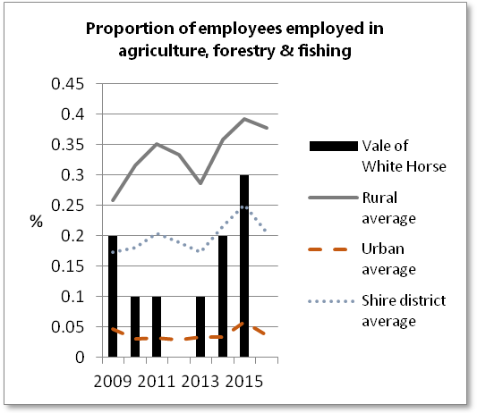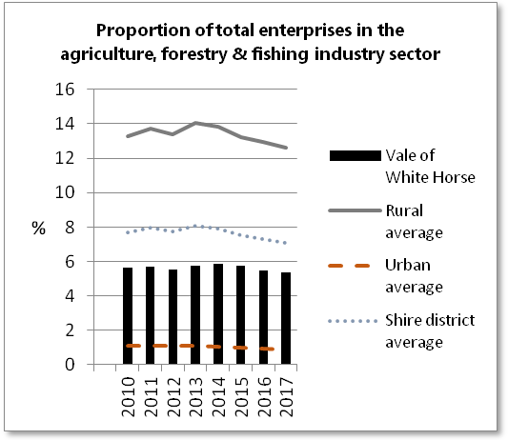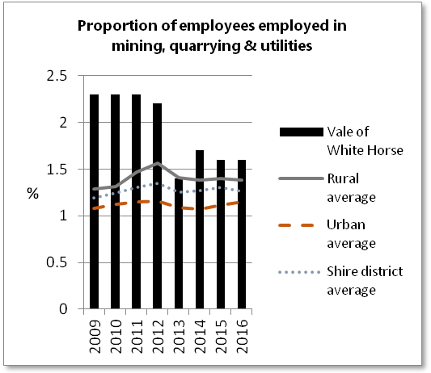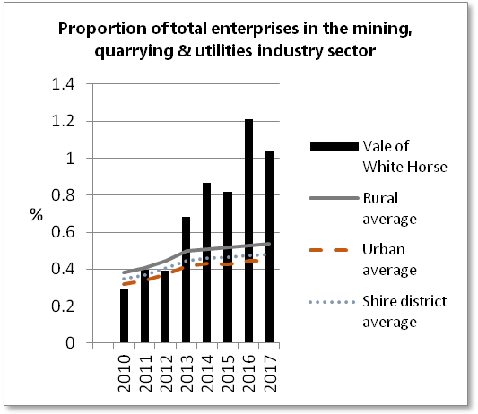
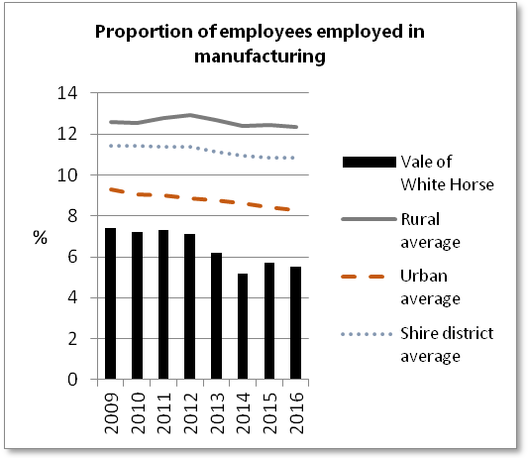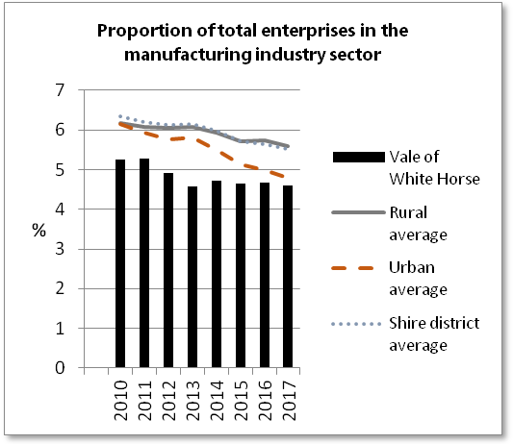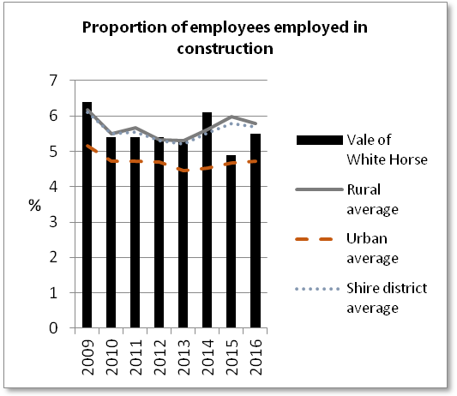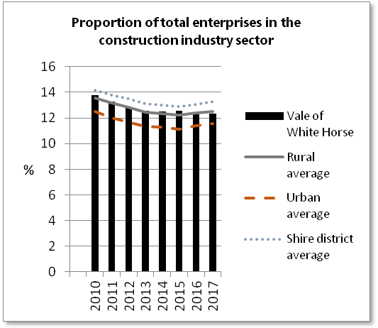
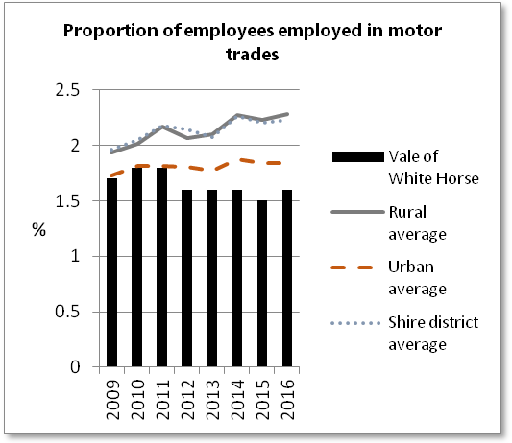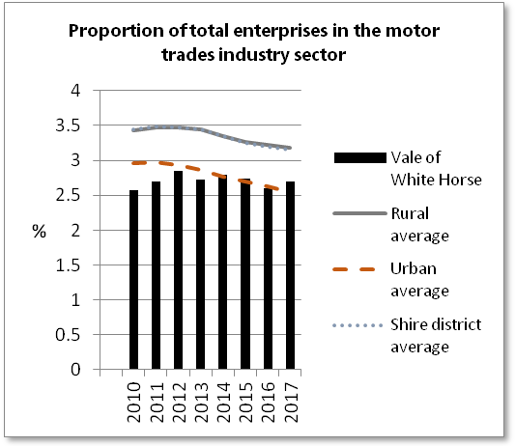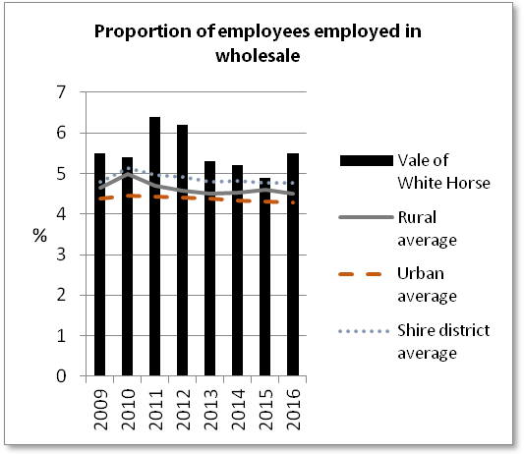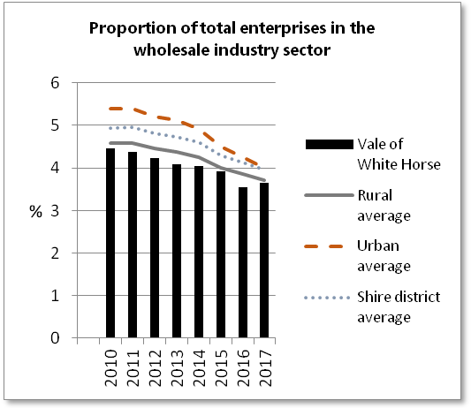
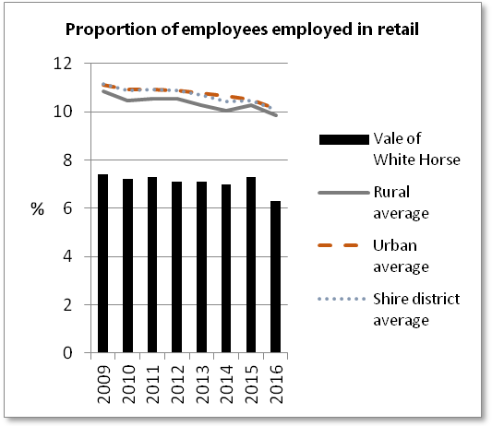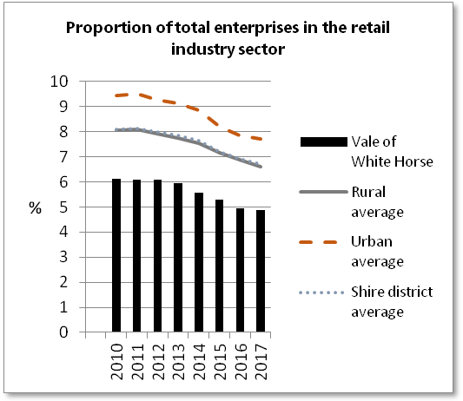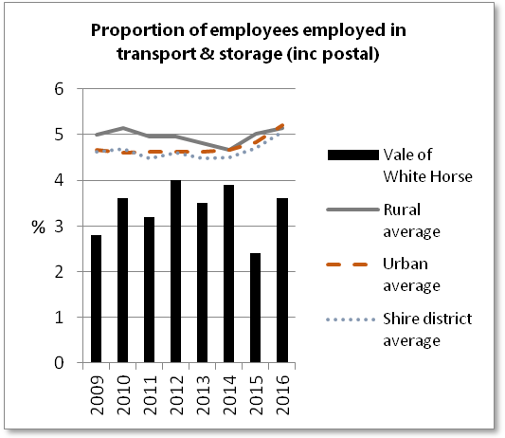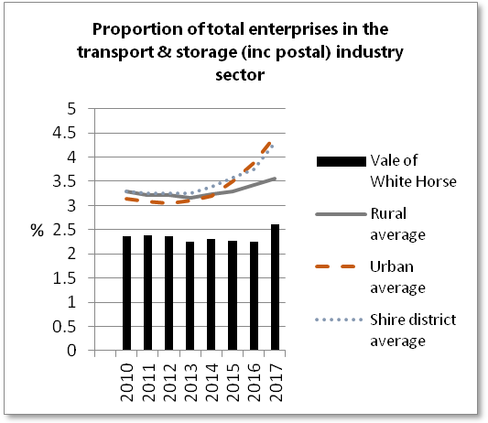
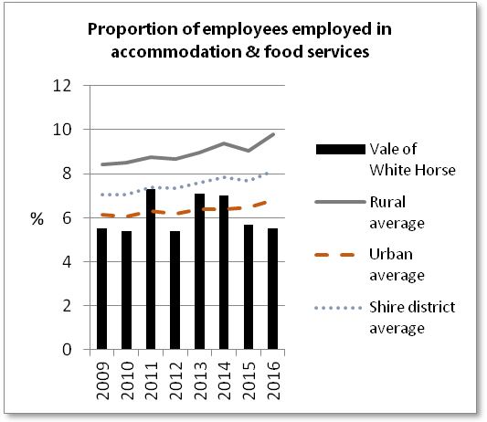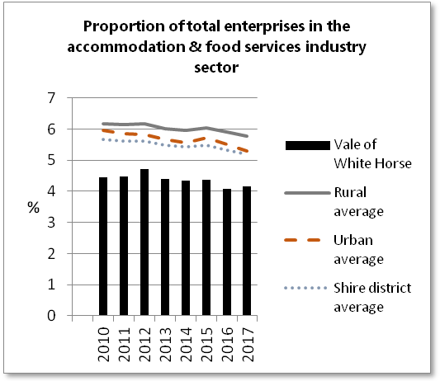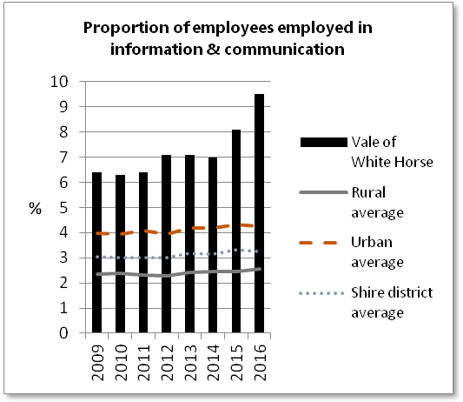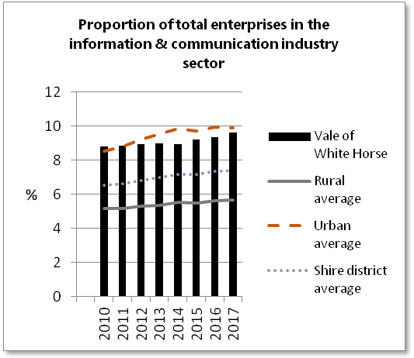
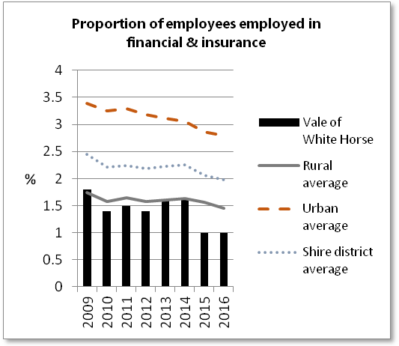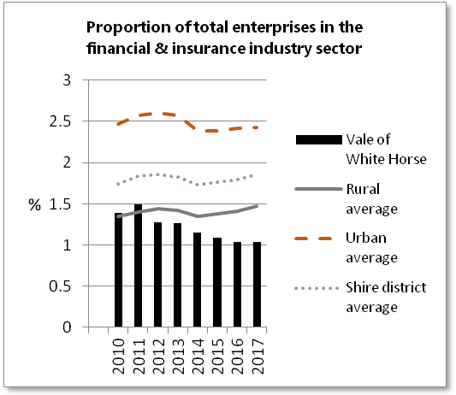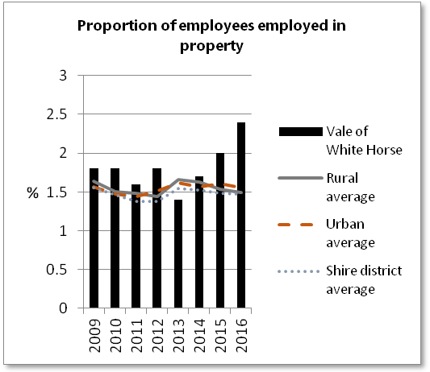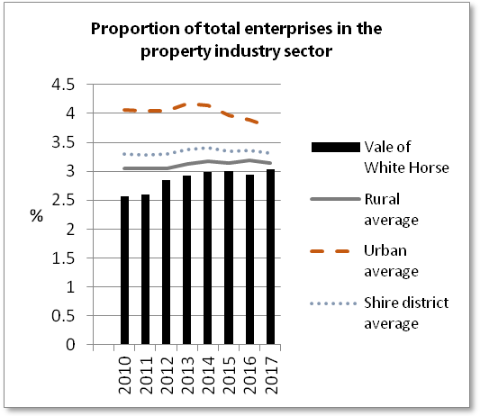
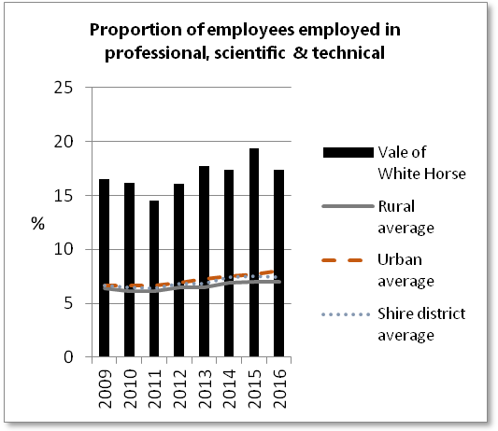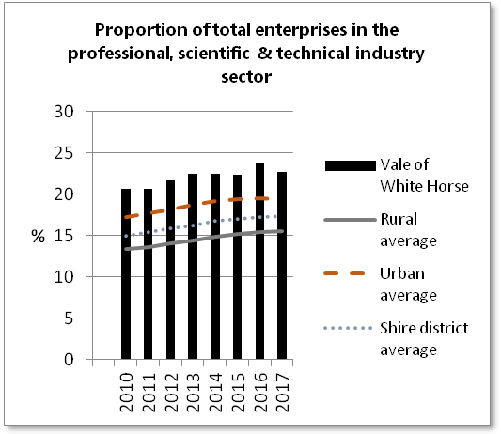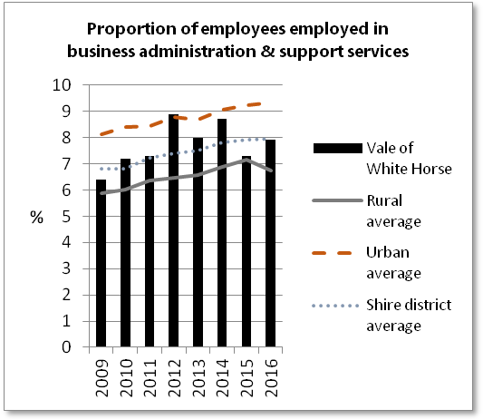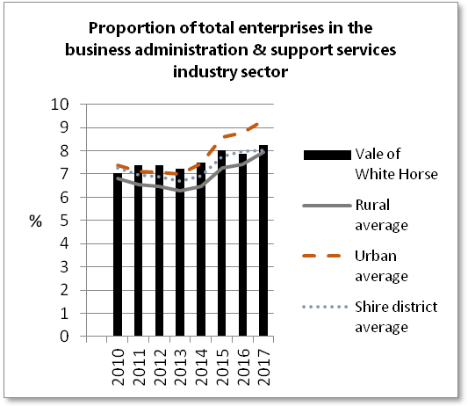
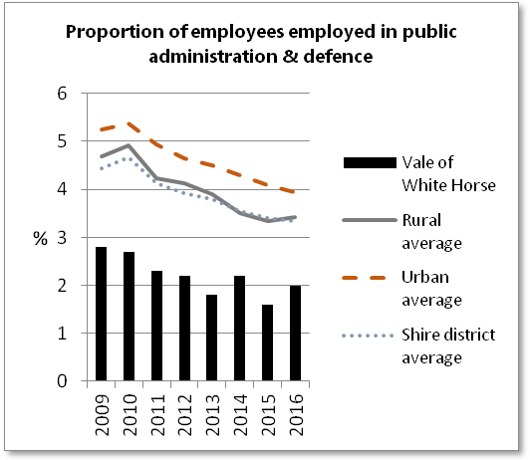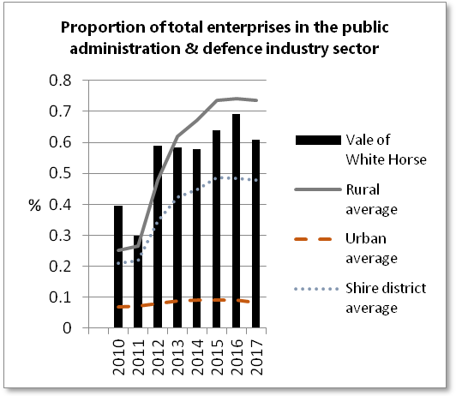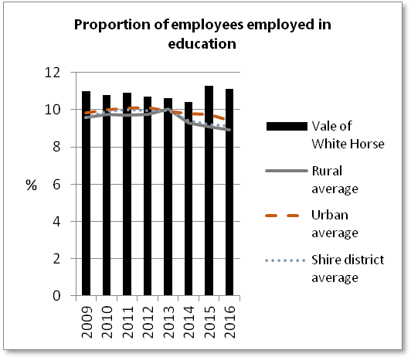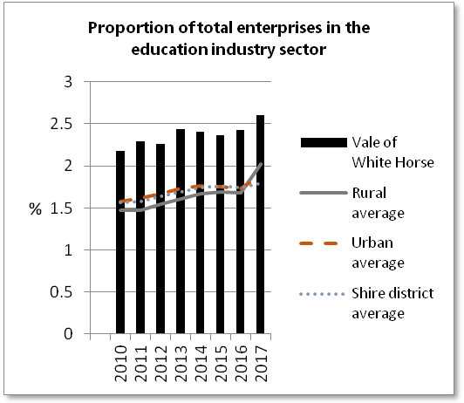
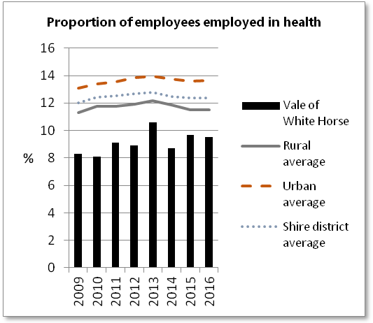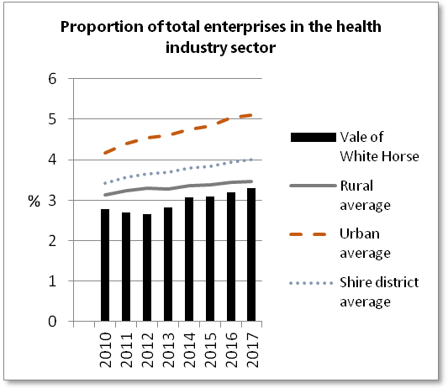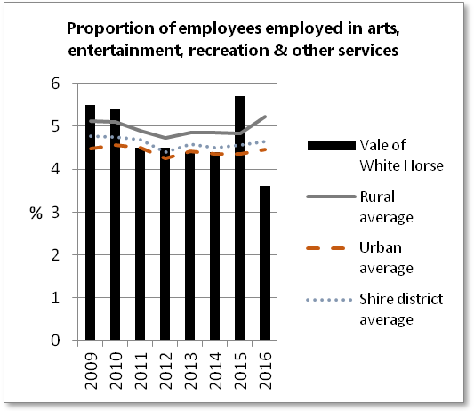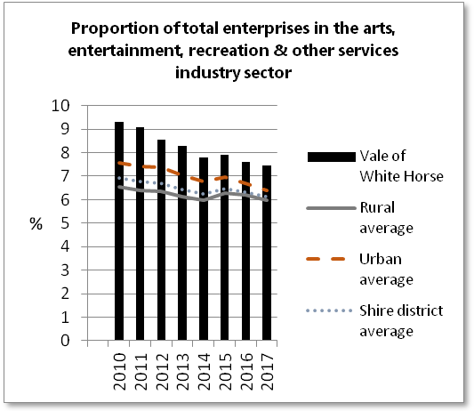

(An Enterprise is the smallest combination of legal units (generally based on VAT and/or PAYE records) which has a certain degree of autonomy within an Enterprise Group. An individual site (for example a factory or shop) in an enterprise is called a local unit.)

Private/public sector employment
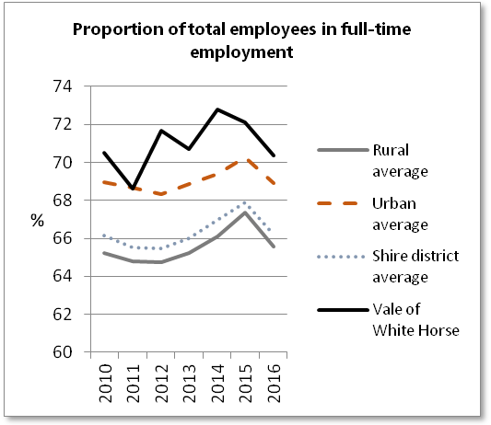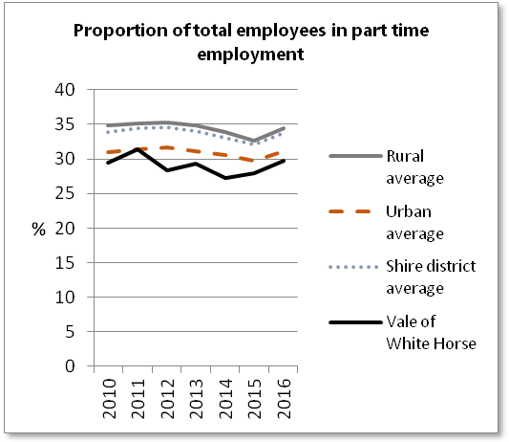
As well as part time employment being more prevalent in some industries as already highlighted, part time employment is also more common in predominantly rural local authority areas than urban areas. In 2016, 34% of employees were in part time employment for predominantly rural areas, in comparison to 31% for predominantly urban areas.
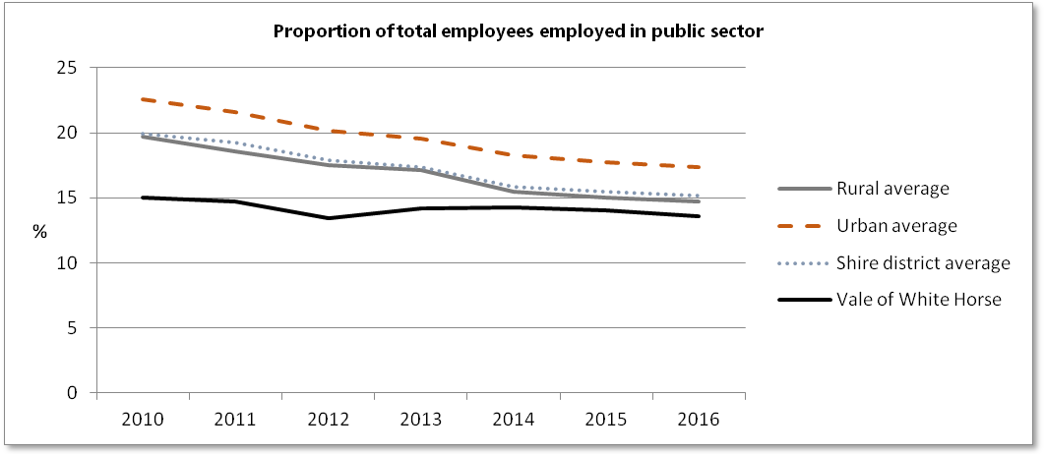
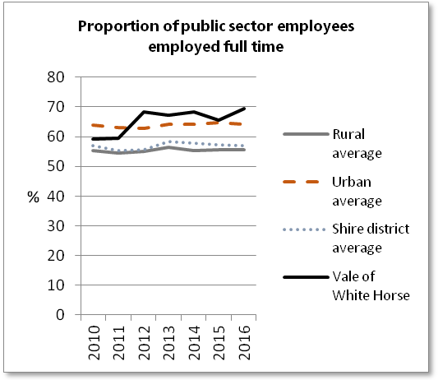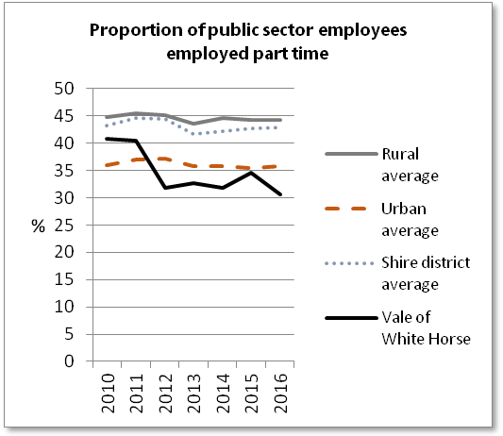
More public sector employment occurs in predominantly urban areas, and again we see more part time employment of public sector workers in the predominantly rural areas (44% of public sector workers in predominantly rural areas were working part time in 2016, compared with 36% for predominantly urban).
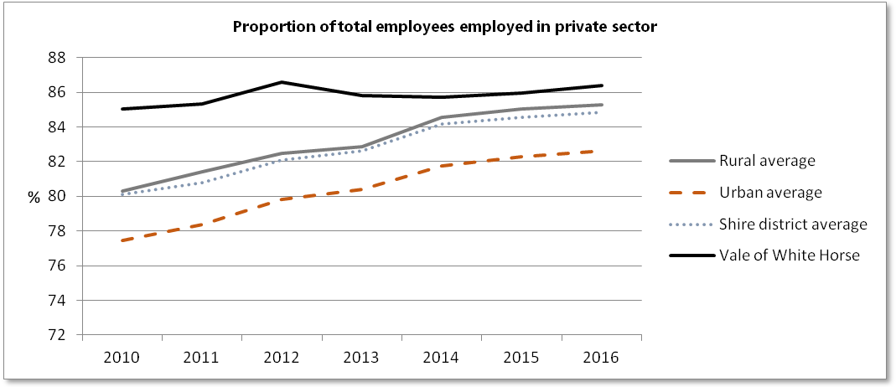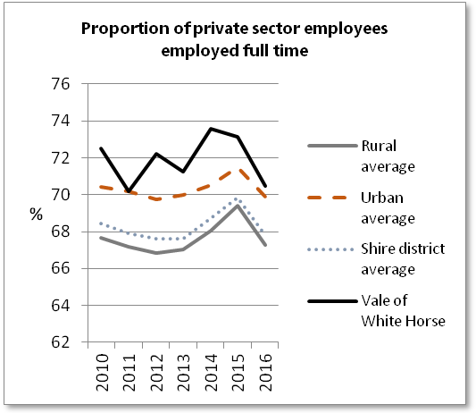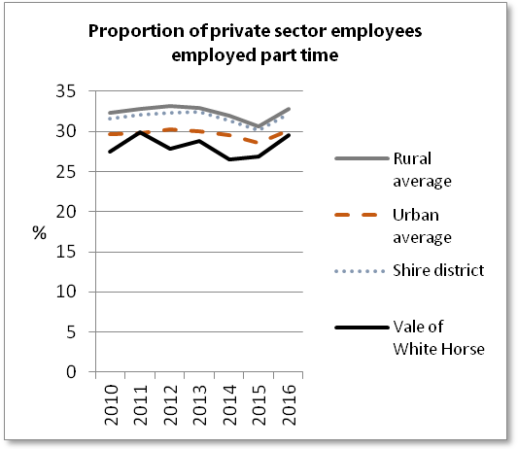
Part time employment is less common within the private sector.

Jobs density
The density figures represent the ratio of total jobs to population aged 16-64. Total jobs includes employees, self-employed, government-supported trainees and HM Forces.
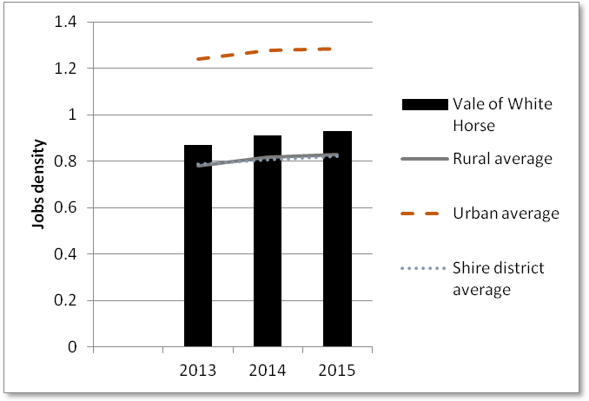
The jobs density in predominantly urban areas is consistently 1.6 times that of predominantly rural. The implication of this on those looking for work in rural areas is compounded by the fact that the proportion of population aged 16-64 on which the density is calculated, in rural areas in smaller than in urban areas. The jobs market is therefore that much tougher for those living in rural local authority areas.

Economic inactivity
A person who is neither in employment nor unemployed is classed as economically inactive. This group includes, for example, all those who were looking after a home or retired. People not in employment who want a job but are not classed as unemployed because they have either not sought work in the last four weeks or are not available to start work are classed as 'economically inactive - wanting a job'.
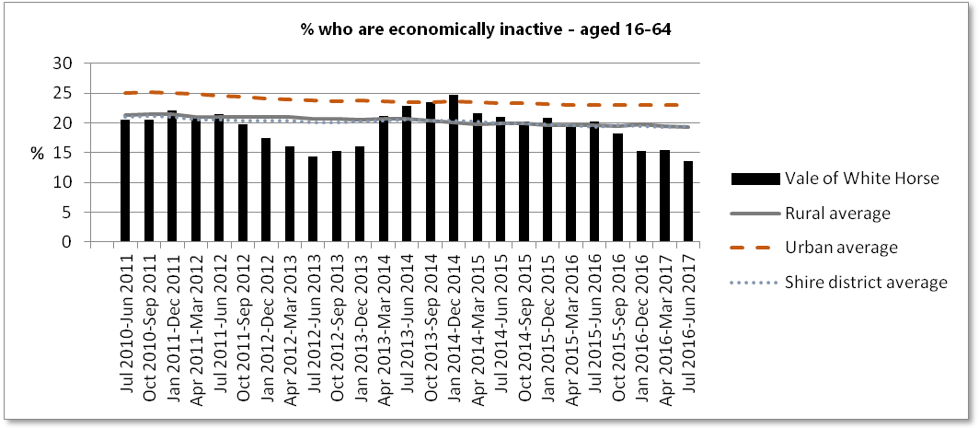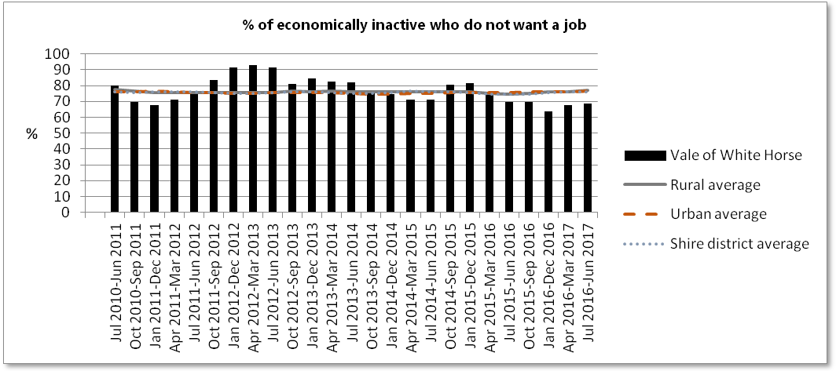

Claimant counts and total benefits

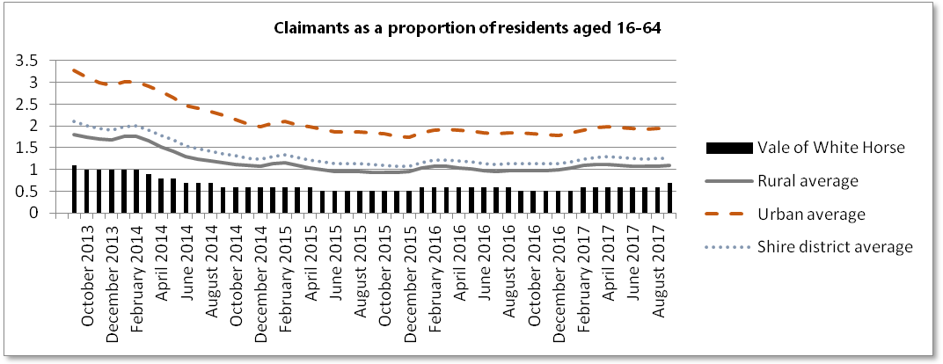
Claimant count: The number of people claiming Jobseeker's Allowance plus those who claim Universal Credit who are out of work.

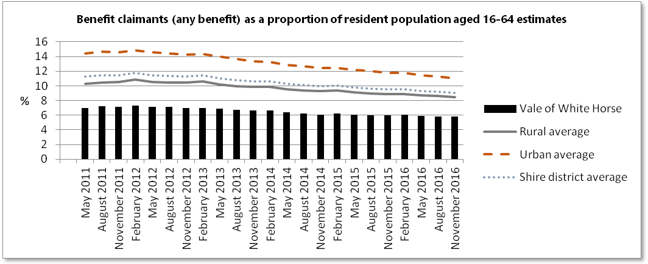

The predominantly urban proportion of claimants is greater than the rural average. It is important to place this in the context of the rural person who has additional challenges compared to their urban counterpart of accessing the benefits system (ie. travel time and cost of travel is greater the further away from the benefits office the claimant lives). The rural person might in such circumstance choose to take part time work in preference (as the part time working statistics provided above indicate) or rely on savings or the assistance of friends and relatives.

Statistical sources

ONS Population estimates
ONS 2014 based population projections
Annual Survey of Hours and Earnings
ONS Annual Population Survey
ONS Business Register and Employment Survey
ONS Inter Departmental Business Register
ONS Annual Civil Service Employment Survey
ONS Jobs density
DWP benefit claimants
ONS Claimant count

